Training Plan

K19T2-Team04-BSS
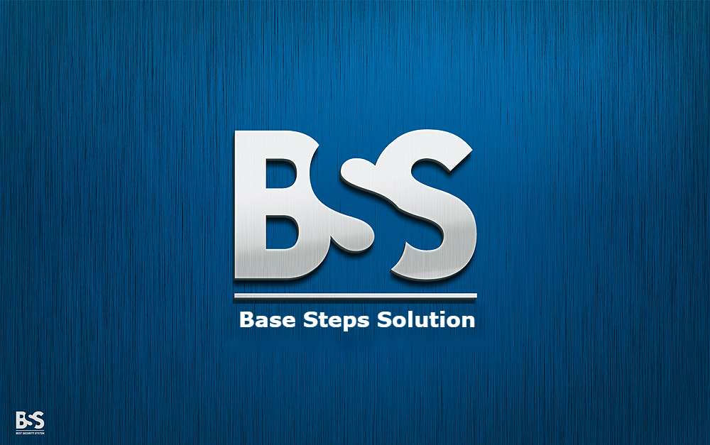

Contents
Trainning Plan 1
Excute 2

Trainning Plan

Excute

